**Air University**

(Multan Campus)

|  |
| --- |
| Department of Computer Sciences |
| Software Engineering |
| **Muhammad Sajjad** |
|  |
| **BSCS-V**  **GIT & GITHUB ASSIGNMENT SOLUTION**  **Exercise 0:**  **Create a Repository with the same name:**  **Exercise 1:Creating a Local Repository:** |

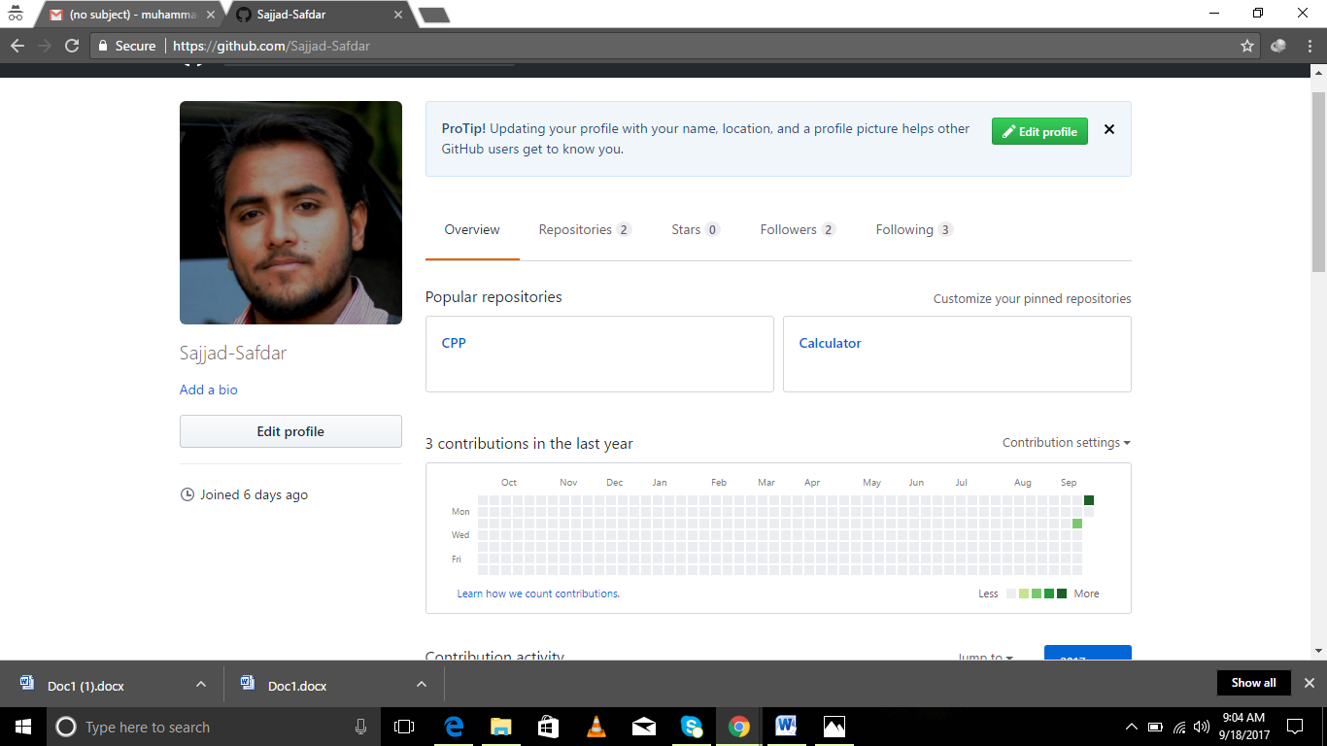

Changing editor and creating a new file:

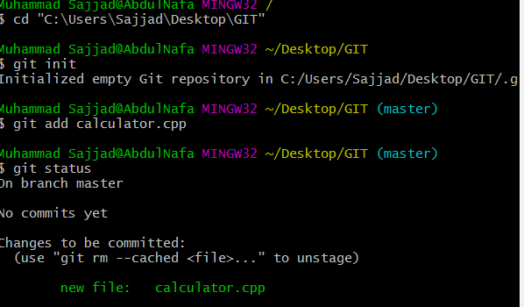

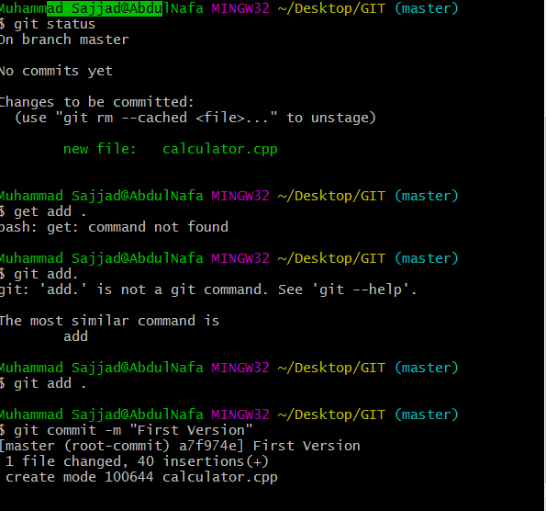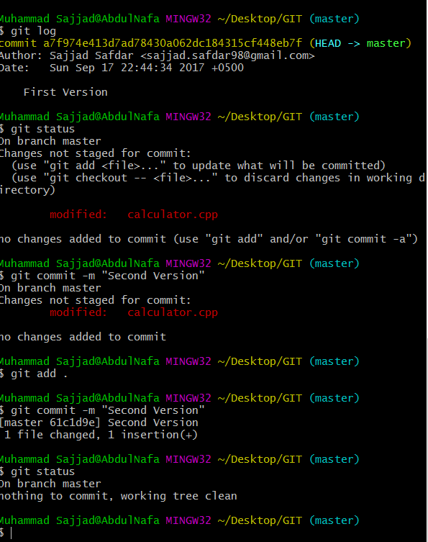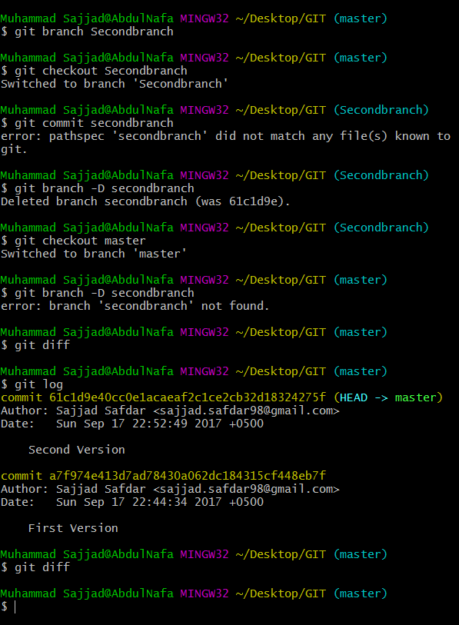

pwd

/c/Users/Sajjad/Desktop

Sajjad@DESKTOP-VGOP2LL MINGW64 ~/Desktop (master)

$ cd assignment

Sajjad @DESKTOP-VGOP2LL MINGW64 ~/Desktop/assignment (master)

$ pwd

/c/Users/Sajjad /Desktop/assignment

Sajjad @DESKTOP-VGOP2LL MINGW64 ~/Desktop/assignment (master)

$ ls

Sajjad @DESKTOP-VGOP2LL MINGW64 ~/Desktop/assignment (master)

$ git add .

Sajjad h@DESKTOP-VGOP2LL MINGW64 ~/Desktop/assignment (master)

$

Sajjad @DESKTOP-VGOP2LL MINGW64 ~/Desktop/assignment (master)

$ git statu

git: 'statu' is not a git command. See 'git --help'.

The most similar commands are

status

stage

stash

Sajjad @DESKTOP-VGOP2LL MINGW64 ~/Desktop/assignment (master)

$ git status

On branch master

No commits yet

Changes to be committed:

(use "git rm --cached <file>..." to unstage)

new file: First.txt

Untracked files:

(use "git add <file>..." to include in what will be committed)

../../.bash_history

../../AppData/

../../Contacts/

../../Creative Cloud Files/

../Continue DEV-C++ Installation.lnk

../IMG_0035.JPG

../IMG_0073.JPG

../IMG_0093.JPG

../Recover My Files v6.lnk

../a751b9c3bae42b88b9c7ab1d71a0766a.jpg

../desktop.ini

../ps-stock-marquee-1440x660.jpg

../tumblr_nnk9j2ozRr1twt4dho8_1280.jpg

../../Documents/

../../Downloads/

../../Favorites/

../../Links/

../../Music/

../../NTUSER.DAT

../../NTUSER.DAT{cb56a6d6-0c49-11e6-a90e-c8aa52d4e633}.TxR.0.regtrans-ms

../../NTUSER.DAT{cb56a6d6-0c49-11e6-a90e-c8aa52d4e633}.TxR.1.regtrans-ms

../../NTUSER.DAT{cb56a6d6-0c49-11e6-a90e-c8aa52d4e633}.TxR.2.regtrans-ms

../../NTUSER.DAT{cb56a6d6-0c49-11e6-a90e-c8aa52d4e633}.TxR.blf

../../NTUSER.DAT{cb56a6d7-0c49-11e6-a90e-c8aa52d4e633}.TM.blf

../../NTUSER.DAT{cb56a6d7-0c49-11e6-a90e-c8aa52d4e633}.TMContainer00000000000000000001.regtrans-ms

../../NTUSER.DAT{cb56a6d7-0c49-11e6-a90e-c8aa52d4e633}.TMContainer00000000000000000002.regtrans-ms

../../OneDrive/

../../Pictures/

../../Saved Games/

../../Videos/

../../ntuser.dat.LOG1

../../ntuser.dat.LOG2

../../ntuser.ini

../../ntuser.pol

Sajjad @DESKTOP-VGOP2LL MINGW64 ~/Desktop/assignment (master)

$ git commit -m "This is our first commit"

*** Please tell me who you are.

Run

git config --global user.email "you@example.com"

git config --global user.name "Your Name"

to set your account's default identity.

Omit --global to set the identity only in this repository.

fatal: unable to auto-detect email address (got ' Sajjad @DESKTOP-VGOP2LL.(none)')

Sajjad @DESKTOP-VGOP2LL MINGW64 ~/Desktop/assignment (master)

$ gir rm --cached first

bash: gir: command not found

Sajjad @DESKTOP-VGOP2LL MINGW64 ~/Desktop/assignment (master)

$ git add first

fatal: pathspec 'first' did not match any files

Sajjad @DESKTOP-VGOP2LL MINGW64 ~/Desktop/assignment (master)

$ git add First

fatal: pathspec 'First' did not match any files

Sajjad @DESKTOP-VGOP2LL MINGW64 ~/Desktop/assignment (master)

$ git add First.txt

Sajjad @DESKTOP-VGOP2LL MINGW64 ~/Desktop/assignment (master)

$ git status

On branch master

No commits yet

Changes to be committed:

(use "git rm --cached <file>..." to unstage)

new file: First.txt

Untracked files:

(use "git add <file>..." to include in what will be committed)

../../.bash_history

../../AppData/

../../Contacts/

../../Creative Cloud Files/

../Continue DEV-C++ Installation.lnk

../IMG_0035.JPG

../IMG_0073.JPG

../IMG_0093.JPG

../Recover My Files v6.lnk

../a751b9c3bae42b88b9c7ab1d71a0766a.jpg

../desktop.ini

../ps-stock-marquee-1440x660.jpg

../tumblr_nnk9j2ozRr1twt4dho8_1280.jpg

../../Documents/

../../Downloads/

../../Favorites/

../../Links/

../../Music/

../../NTUSER.DAT

../../NTUSER.DAT{cb56a6d6-0c49-11e6-a90e-c8aa52d4e633}.TxR.0.regtrans-ms

../../NTUSER.DAT{cb56a6d6-0c49-11e6-a90e-c8aa52d4e633}.TxR.1.regtrans-ms

../../NTUSER.DAT{cb56a6d6-0c49-11e6-a90e-c8aa52d4e633}.TxR.2.regtrans-ms

../../NTUSER.DAT{cb56a6d6-0c49-11e6-a90e-c8aa52d4e633}.TxR.blf

../../NTUSER.DAT{cb56a6d7-0c49-11e6-a90e-c8aa52d4e633}.TM.blf

../../NTUSER.DAT{cb56a6d7-0c49-11e6-a90e-c8aa52d4e633}.TMContainer00000000000000000001.regtrans-ms

../../NTUSER.DAT{cb56a6d7-0c49-11e6-a90e-c8aa52d4e633}.TMContainer00000000000000000002.regtrans-ms

../../OneDrive/

../../Pictures/

../../Saved Games/

../../Videos/

../../ntuser.dat.LOG1

../../ntuser.dat.LOG2

../../ntuser.ini

../../ntuser.pol

Sajjad @DESKTOP-VGOP2LL MINGW64 ~/Desktop/assignment (master)

$ gir rm --cached first

bash: gir: command not found

Sajjad @DESKTOP-VGOP2LL MINGW64 ~/Desktop/assignment (master)

$ git commit -m "This is our first commit"

*** Please tell me who you are.

Run

git config --global user.email "you@example.com"

git config --global user.name "Your Name"

to set your account's default identity.

Omit --global to set the identity only in this repository.

fatal: unable to auto-detect email address (got ' Sajjad @DESKTOP-VGOP2LL.(none)')

Sajjad@DESKTOP-VGOP2LL MINGW64 ~/Desktop/assignment (master)

$ git add First.txt

Sajjad @DESKTOP-VGOP2LL MINGW64 ~/Desktop/assignment (master)

$ git init

Initialized empty Git repository in C:/Users/ Sajjad /Desktop/assignment/.git/

Sajjad @DESKTOP-VGOP2LL MINGW64 ~/Desktop/assignment (master)

$ cd ›~

bash: cd: $'\302\233~': No such file or directory

\

Sajjad @DESKTOP-VGOP2LL MINGW64 ~/Desktop/assignment (master)

$ la

bash: la: command not found

Sajjad @DESKTOP-VGOP2LL MINGW64 ~/Desktop/assignment (master)

$ ls

First.txt

Sajjad @DESKTOP-VGOP2LL MINGW64 ~/Desktop/assignment (master)

$ git config --global core.editor notepad

Sajjad @DESKTOP-VGOP2LL MINGW64 ~/Desktop/assignment (master)

$ notpad First.txt

bash: notpad: command not found

Sajjad @DESKTOP-VGOP2LL MINGW64 ~/Desktop/assignment (master)

$ notepad First.txt

git stats

git status

Sajjad @DESKTOP-VGOP2LL MINGW64 ~/Desktop/assignment (master)

$ git stats

git: 'stats' is not a git command. See 'git --help'.

The most similar command is

status

Sajjad @DESKTOP-VGOP2LL MINGW64 ~/Desktop/assignment (master)

$ git status

On branch master

No commits yet

Untracked files:

(use "git add <file>..." to include in what will be committed)

First.txt

nothing added to commit but untracked files present (use "git add" to track)

Sajjad @DESKTOP-VGOP2LL MINGW64 ~/Desktop/assignment (master)

$ git add First.txt

Sajjad @DESKTOP-VGOP2LL MINGW64 ~/Desktop/assignment (master)

$ git status

On branch master

No commits yet

Changes to be committed:

(use "git rm --cached <file>..." to unstage)

new file: First.txt

Sajjad @DESKTOP-VGOP2LL MINGW64 ~/Desktop/assignment (master)

$ git add src

fatal: pathspec 'src' did not match any files

Sajjad @DESKTOP-VGOP2LL MINGW64 ~/Desktop/assignment (master)

$ git add scr

fatal: pathspec 'scr' did not match any files

Sajjad @DESKTOP-VGOP2LL MINGW64 ~/Desktop/assignment (master)

$ git commit -m 'Commit changes'

*** Please tell me who you are.

Run

git config --global user.email "you@example.com"

git config --global user.name "Your Name"

to set your account's default identity.

Omit --global to set the identity only in this repository.

fatal: unable to auto-detect email address (got ' Sajjad @DESKTOP-VGOP2LL.(none)')

Sajjad @DESKTOP-VGOP2LL MINGW64 ~/Desktop/assignment (master)

$

**Exercise 2:**

**Cloning an existing repository:**

**Exercise 3:**

Sajjad @DESKTOP-VGOP2LL MINGW64 ~/calculator (master)

$ git clone https://github.com/burrisetest/BestTechReferences.git

Cloning into 'BestTechReferences'...

remote: Counting objects: 138, done.

remote: Total 138 (delta 0), reused 0 (delta 0), pack-reused 138

Receiving objects: 100% (138/138), 28.58 KiB | 164.00 KiB/s, done.

Resolving deltas: 100% (36/36), done.

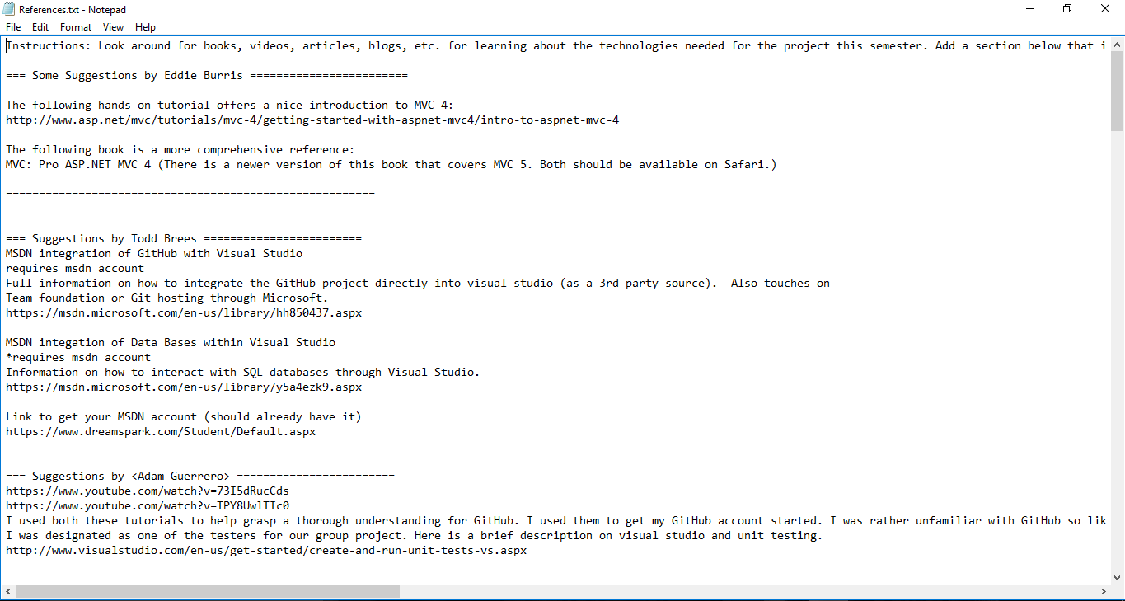

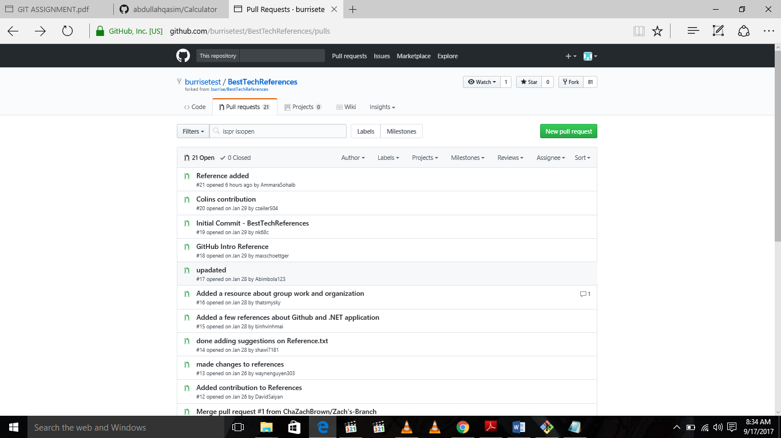

**Exercise 4:**

**Adding a Remote:**

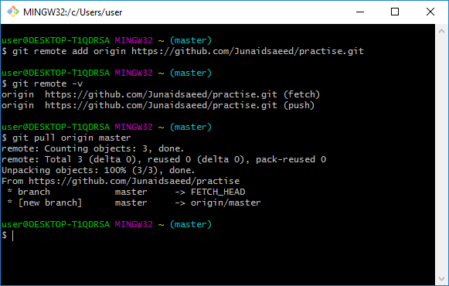

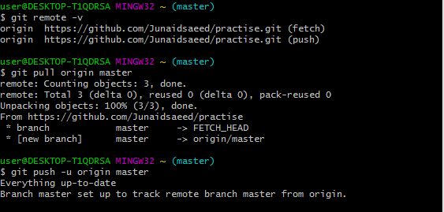

**Exercise 5**

**Branching and merging:**

mkdir website

Sajjad @DESKTOP-VGOP2LL MINGW64 ~/calculator/BestTechReferences (EddiesContribution)

$ cd website

Sajjad @DESKTOP-VGOP2LL MINGW64 ~/calculator/BestTechReferences/website (EddiesContribution)

$ git init

Initialized empty Git repository in C:/Users/ Sajjad /calculator/BestTechReferences/website/.git/

Sajjad @DESKTOP-VGOP2LL MINGW64 ~/calculator/BestTechReferences/website (master)

$ notpad index.html

bash: notpad: command not found

Sajjad @DESKTOP-VGOP2LL MINGW64 ~/calculator/BestTechReferences/website (master)

$ notepad index.html

Sajjad @DESKTOP-VGOP2LL MINGW64 ~/calculator/BestTechReferences/website (master)

$ git add index.html

Sajjad @DESKTOP-VGOP2LL MINGW64 ~/calculator/BestTechReferences/website (master)

$ git commit -m 'initial checkin'

[master (root-commit) f260a64] initial checkin

1 file changed, 10 insertions(+)

create mode 100644 index.html

Sajjad @DESKTOP-VGOP2LL MINGW64 ~/calculator/BestTechReferences/website (master)

$ git branch

* master

Sajjad @DESKTOP-VGOP2LL MINGW64 ~/calculator/BestTechReferences/website (master)

$ git checkout contactinfo

error: pathspec 'contactinfo' did not match any file(s) known to git.

Sajjad @DESKTOP-VGOP2LL MINGW64 ~/calculator/BestTechReferences/website (master)

$

Sajjad @DESKTOP-VGOP2LL MINGW64 ~/calculator/BestTechReferences/website (master)

$

Sajjad @DESKTOP-VGOP2LL MINGW64 ~/calculator/BestTechReferences/website (master)

$

Sajjad @DESKTOP-VGOP2LL MINGW64 ~/calculator/BestTechReferences/website (master)

$

Sajjad @DESKTOP-VGOP2LL MINGW64 ~/calculator/BestTechReferences/website (master)

$ $ not

bash: $: command not found

Sajjad @DESKTOP-VGOP2LL MINGW64 ~/calculator/BestTechReferences/website (master)

$ git branch contactinfo

Sajjad @DESKTOP-VGOP2LL MINGW64 ~/calculator/BestTechReferences/website (master)

$ git branch

contactinfo

* master

Sajjad @DESKTOP-VGOP2LL MINGW64 ~/calculator/BestTechReferences/website (master)

$ git checkout contactinfo

Switched to branch 'contactinfo'

Sajjad @DESKTOP-VGOP2LL MINGW64 ~/calculator/BestTechReferences/website (contactinfo)

$ notepad index.html

Sajjad @DESKTOP-VGOP2LL MINGW64 ~/calculator/BestTechReferences/website (contactinfo)

$ git add index.html

Sajjad @DESKTOP-VGOP2LL MINGW64 ~/calculator/BestTechReferences/website (contactinfo)

$ git commit –m ‘add phone contact’

error: pathspec '–m' did not match any file(s) known to git.

error: pathspec '‘add' did not match any file(s) known to git.

error: pathspec 'phone' did not match any file(s) known to git.

error: pathspec 'contact’' did not match any file(s) known to git.

Sajjad @DESKTOP-VGOP2LL MINGW64 ~/calculator/BestTechReferences/website (contactinfo)

$

Sajjad @DESKTOP-VGOP2LL MINGW64 ~/calculator/BestTechReferences/website (contactinfo)

$

Sajjad @DESKTOP-VGOP2LL MINGW64 ~/calculator/BestTechReferences/website (contactinfo)

$ git commit -m 'add phone contact'

[contactinfo 95c71c8] add phone contact

1 file changed, 2 insertions(+)

Sajjad @DESKTOP-VGOP2LL MINGW64 ~/calculator/BestTechReferences/website (contactinfo)

$ git checkout master

Switched to branch 'master'

Sajjad @DESKTOP-VGOP2LL MINGW64 ~/calculator/BestTechReferences/website (master)

$ notepad index.html

Sajjad @DESKTOP-VGOP2LL MINGW64 ~/calculator/BestTechReferences/website (master)

$ git add index.html

Sajjad @DESKTOP-VGOP2LL MINGW64 ~/calculator/BestTechReferences/website (master)

$ notepad index.html

Sajjad @DESKTOP-VGOP2LL MINGW64 ~/calculator/BestTechReferences/website (master)

$ cat index.html

<html>

<head>

<title>Achme Inc.</title>

</head>

<body>

<h1>We are open for business:</h1>

<ol>

<li>Monday</li>

<li>Wednesday</li>

<li>Friday</li>

</ol>

</body>

</html>

Sajjad @DESKTOP-VGOP2LL MINGW64 ~/calculator/BestTechReferences/website (master)

$ git checkout contactinfo

error: Your local changes to the following files would be overwritten by checkout:

index.html

Please commit your changes or stash them before you switch branches.

Aborting

Sajjad @DESKTOP-VGOP2LL MINGW64 ~/calculator/BestTechReferences/website (master)

$ git checkout contactinfo

error: Your local changes to the following files would be overwritten by checkout:

index.html

Please commit your changes or stash them before you switch branches.

Aborting

Sajjad @DESKTOP-VGOP2LL MINGW64 ~/calculator/BestTechReferences/website (master)

$ notepad index.html

Sajjad @DESKTOP-VGOP2LL MINGW64 ~/calculator/BestTechReferences/website (master)

$ git add index.html

Sajjad @DESKTOP-VGOP2LL MINGW64 ~/calculator/BestTechReferences/website (master)

$ git commit -m 'add phone contact'

[master 0e18711] add phone contact

1 file changed, 2 insertions(+)

Sajjad @DESKTOP-VGOP2LL MINGW64 ~/calculator/BestTechReferences/website (master)

$ git checkout master

Already on 'master'

Sajjad @DESKTOP-VGOP2LL MINGW64 ~/calculator/BestTechReferences/website (master)

$ notepad index.html

Sajjad @DESKTOP-VGOP2LL MINGW64 ~/calculator/BestTechReferences/website (master)

$ git add index.html

Sajjad @DESKTOP-VGOP2LL MINGW64 ~/calculator/BestTechReferences/website (master)

$ git commit -m 'add title'

[master c0928b9] add title

1 file changed, 4 insertions(+), 3 deletions(-)

Sajjad @DESKTOP-VGOP2LL MINGW64 ~/calculator/BestTechReferences/website (master)

$ git branch

contactinfo

* master

Sajjad @DESKTOP-VGOP2LL MINGW64 ~/calculator/BestTechReferences/website (master)

$ get merge contactinfo

bash: get: command not found

Sajjad @DESKTOP-VGOP2LL MINGW64 ~/calculator/BestTechReferences/website (master)

$ git merge contact indo

merge: contact - not something we can merge

Sajjad @DESKTOP-VGOP2LL MINGW64 ~/calculator/BestTechReferences/website (master)

$ git merge contact info

merge: contact - not something we can merge

Sajjad @DESKTOP-VGOP2LL MINGW64 ~/calculator/BestTechReferences/website (master)

$ git merge contactinfo

Auto-merging index.html

unix2dos: converting file C:/Users/ Sajjad /calculator/BestTechReferences/website/.git/MERGE_MSG to DOS format...

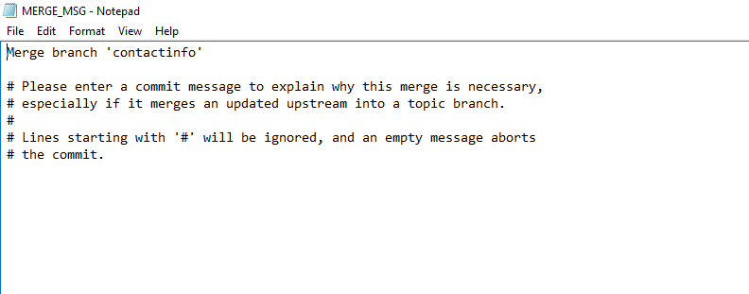

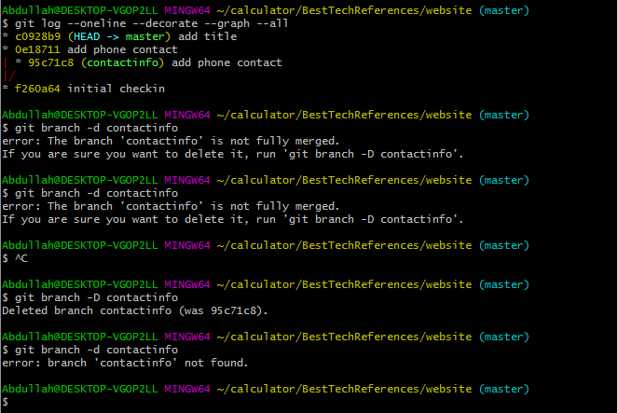

**Exercise 5**

**Branching and merging with conflicts:**

mkdir website

Sajjad @DESKTOP-VGOP2LL MINGW64 ~/calculator/BestTechReferences (EddiesContribution)

$ cd website

Sajjad @DESKTOP-VGOP2LL MINGW64 ~/calculator/BestTechReferences/website (EddiesContribution)

$ git init

Initialized empty Git repository in C:/Users/ Sajjad /calculator/BestTechReferences/website/.git/

Sajjad @DESKTOP-VGOP2LL MINGW64 ~/calculator/BestTechReferences/website (master)

$ notpad index.html

bash: notpad: command not found

Sajjad @DESKTOP-VGOP2LL MINGW64 ~/calculator/BestTechReferences/website (master)

$ notepad index.html

Sajjad @DESKTOP-VGOP2LL MINGW64 ~/calculator/BestTechReferences/website (master)

$ git add index.html

Sajjad @DESKTOP-VGOP2LL MINGW64 ~/calculator/BestTechReferences/website (master)

$ git commit -m 'initial checkin'

[master (root-commit) f260a64] initial checkin

1 file changed, 10 insertions(+)

create mode 100644 index.html

Sajjad @DESKTOP-VGOP2LL MINGW64 ~/calculator/BestTechReferences/website (master)

$ git branch

* master

Sajjad @DESKTOP-VGOP2LL MINGW64 ~/calculator/BestTechReferences/website (master)

$ git checkout contactinfo

error: pathspec 'contactinfo' did not match any file(s) known to git.

Sajjad @DESKTOP-VGOP2LL MINGW64 ~/calculator/BestTechReferences/website (master)

$

Sajjad @DESKTOP-VGOP2LL MINGW64 ~/calculator/BestTechReferences/website (master)

$

Sajjad @DESKTOP-VGOP2LL MINGW64 ~/calculator/BestTechReferences/website (master)

$

Sajjad @DESKTOP-VGOP2LL MINGW64 ~/calculator/BestTechReferences/website (master)

$

Sajjad @DESKTOP-VGOP2LL MINGW64 ~/calculator/BestTechReferences/website (master)

$ $ not

bash: $: command not found

Sajjad @DESKTOP-VGOP2LL MINGW64 ~/calculator/BestTechReferences/website (master)

$ git branch contactinfo

Sajjad @DESKTOP-VGOP2LL MINGW64 ~/calculator/BestTechReferences/website (master)

$ git branch

contactinfo

* master

Sajjad @DESKTOP-VGOP2LL MINGW64 ~/calculator/BestTechReferences/website (master)

$ git checkout contactinfo

Switched to branch 'contactinfo'

Sajjad @DESKTOP-VGOP2LL MINGW64 ~/calculator/BestTechReferences/website (contactinfo)

$ notepad index.html

Sajjad @DESKTOP-VGOP2LL MINGW64 ~/calculator/BestTechReferences/website (contactinfo)

$ git add index.html

Sajjad @DESKTOP-VGOP2LL MINGW64 ~/calculator/BestTechReferences/website (contactinfo)

$ git commit –m ‘add phone contact’

error: pathspec '–m' did not match any file(s) known to git.

error: pathspec '‘add' did not match any file(s) known to git.

error: pathspec 'phone' did not match any file(s) known to git.

error: pathspec 'contact’' did not match any file(s) known to git.

Sajjad @DESKTOP-VGOP2LL MINGW64 ~/calculator/BestTechReferences/website (contactinfo)

$

Sajjad @DESKTOP-VGOP2LL MINGW64 ~/calculator/BestTechReferences/website (contactinfo)

$

Sajjad @DESKTOP-VGOP2LL MINGW64 ~/calculator/BestTechReferences/website (contactinfo)

$ git commit -m 'add phone contact'

[contactinfo 95c71c8] add phone contact

1 file changed, 2 insertions(+)

Sajjad @DESKTOP-VGOP2LL MINGW64 ~/calculator/BestTechReferences/website (contactinfo)

$ git checkout master

Switched to branch 'master'

Sajjad @DESKTOP-VGOP2LL MINGW64 ~/calculator/BestTechReferences/website (master)

$ notepad index.html

Sajjad @DESKTOP-VGOP2LL MINGW64 ~/calculator/BestTechReferences/website (master)

$ git add index.html

Sajjad @DESKTOP-VGOP2LL MINGW64 ~/calculator/BestTechReferences/website (master)

$ notepad index.html

Sajjad @DESKTOP-VGOP2LL MINGW64 ~/calculator/BestTechReferences/website (master)

$ cat index.html

<html>

<head>

<title>Achme Inc.</title>

</head>

<body>

<h1>We are open for business:</h1>

<ol>

<li>Monday</li>

<li>Wednesday</li>

<li>Friday</li>

</ol>

</body>

</html>

Sajjad @DESKTOP-VGOP2LL MINGW64 ~/calculator/BestTechReferences/website (master)

$ git checkout contactinfo

error: Your local changes to the following files would be overwritten by checkout:

index.html

Please commit your changes or stash them before you switch branches.

Aborting

Sajjad @DESKTOP-VGOP2LL MINGW64 ~/calculator/BestTechReferences/website (master)

$ git checkout contactinfo

error: Your local changes to the following files would be overwritten by checkout:

index.html

Please commit your changes or stash them before you switch branches.

Aborting

Sajjad @DESKTOP-VGOP2LL MINGW64 ~/calculator/BestTechReferences/website (master)

$ notepad index.html

Sajjad @DESKTOP-VGOP2LL MINGW64 ~/calculator/BestTechReferences/website (master)

$ git add index.html

Sajjad @DESKTOP-VGOP2LL MINGW64 ~/calculator/BestTechReferences/website (master)

$ git commit -m 'add phone contact'

[master 0e18711] add phone contact

1 file changed, 2 insertions(+)

Sajjad @DESKTOP-VGOP2LL MINGW64 ~/calculator/BestTechReferences/website (master)

$ git checkout master

Already on 'master'

Sajjad @DESKTOP-VGOP2LL MINGW64 ~/calculator/BestTechReferences/website (master)

$ notepad index.html

Sajjad @DESKTOP-VGOP2LL MINGW64 ~/calculator/BestTechReferences/website (master)

$ git add index.html

Sajjad @DESKTOP-VGOP2LL MINGW64 ~/calculator/BestTechReferences/website (master)

$ git commit -m 'add title'

[master c0928b9] add title

1 file changed, 4 insertions(+), 3 deletions(-)

Sajjad @DESKTOP-VGOP2LL MINGW64 ~/calculator/BestTechReferences/website (master)

$ git branch

contactinfo

* master

Sajjad @DESKTOP-VGOP2LL MINGW64 ~/calculator/BestTechReferences/website (master)

$ get merge contactinfo

bash: get: command not found

Sajjad @DESKTOP-VGOP2LL MINGW64 ~/calculator/BestTechReferences/website (master)

$ git merge contact indo

merge: contact - not something we can merge

Sajjad @DESKTOP-VGOP2LL MINGW64 ~/calculator/BestTechReferences/website (master)

$ git merge contact info

merge: contact - not something we can merge

Sajjad @DESKTOP-VGOP2LL MINGW64 ~/calculator/BestTechReferences/website (master)

$ git merge contactinfo

Auto-merging index.html

unix2dos: converting file C:/Users/ Sajjad /calculator/BestTechReferences/website/.git/MERGE_MSG to DOS format...





**Exercise 6:**

**Branching and remotes:**

user@DESKTOP-T1QDRSA MINGW32 ~ (master)

$ git remote

origin

user@DESKTOP-T1QDRSA MINGW32 ~ (master)

$ git remote -v

origin https://github.com/ Sajjad Safdar/practise.git (fetch)

origin https://github.com/ Sajjad Safdar /practise.git (push)

user@DESKTOP-T1QDRSA MINGW32 ~ (master)

$ git remote add upstream https://github.com/ Sajjad Safdar /practise

user@DESKTOP-T1QDRSA MINGW32 ~ (master)

$ git branch -r

origin/master

user@DESKTOP-T1QDRSA MINGW32 ~ (master)

$ git checkout origin/feature123

error: pathspec 'origin/feature123' did not match any file(s) known to git.

user@DESKTOP-T1QDRSA MINGW32 ~ (master)

$ git branch-r

git: 'branch-r' is not a git command. See 'git --help'.

user@DESKTOP-T1QDRSA MINGW32 ~ (master)

$ git branch --r

origin/master

user@DESKTOP-T1QDRSA MINGW32 ~ (master)

$ is

bash: is: command not found

user@DESKTOP-T1QDRSA MINGW32 ~ (master)

$ Is

bash: Is: command not found

user@DESKTOP-T1QDRSA MINGW32 ~ (master)

$ git checkout origin/feature123

error: pathspec 'origin/feature123' did not match any file(s) known to git.

user@DESKTOP-T1QDRSA MINGW32 ~ (master)

$ Is

bash: Is: command not found

user@DESKTOP-T1QDRSA MINGW32 ~ (master)

$ git checkout master

Already on 'master'

Your branch is up-to-date with 'origin/master'.

user@DESKTOP-T1QDRSA MINGW32 ~ (master)

$ git clone https://github.com/ Sajjad Safdar /practise.git

Cloning into 'practise'...

remote: Counting objects: 3, done.

remote: Total 3 (delta 0), reused 0 (delta 0), pack-reused 0

Unpacking objects: 100% (3/3), done.

user@DESKTOP-T1QDRSA MINGW32 ~ (master)

$ cd practise

user@DESKTOP-T1QDRSA MINGW32 ~/practise (master)

$ git branch -r

origin/HEAD -> origin/master

origin/master

user@DESKTOP-T1QDRSA MINGW32 ~/practise (master)

$ cd

user@DESKTOP-T1QDRSA MINGW32 ~ (master)

$ git clone https://github.com/ Sajjad Safdar /practise.git practisecopy

Cloning into 'practisecopy'...

remote: Counting objects: 3, done.

remote: Total 3 (delta 0), reused 0 (delta 0), pack-reused 0

Unpacking objects: 100% (3/3), done.

user@DESKTOP-T1QDRSA MINGW32 ~ (master)

$ cd practise

user@DESKTOP-T1QDRSA MINGW32 ~/practise (master)

$ git checkout -b fix 123

fatal: '123' is not a commit and a branch 'fix' cannot be created from it

user@DESKTOP-T1QDRSA MINGW32 ~/practise (master)

$ git push

Everything up-to-date

user@DESKTOP-T1QDRSA MINGW32 ~/practise (master)

$ git push origin fix 123

error: src refspec fix does not match any.

error: src refspec 123 does not match any.

error: failed to push some refs to 'https://github.com/ Sajjad Safdar /practise.git'

user@DESKTOP-T1QDRSA MINGW32 ~/practise (master)

$ git push origin practisecopy

error: src refspec practisecopy does not match any.

error: failed to push some refs to 'https://github.com/ Sajjad Safdar /practise.git'

user@DESKTOP-T1QDRSA MINGW32 ~/practise (master)

$ cd /practisecopy

bash: cd: /practisecopy: No such file or directory

user@DESKTOP-T1QDRSA MINGW32 ~/practise (master)

$ git branch -r

origin/HEAD -> origin/master

origin/master

user@DESKTOP-T1QDRSA MINGW32 ~/practise (master)

$ git fetch origin

user@DESKTOP-T1QDRSA MINGW32 ~/practise (master)

$ git branch -r

origin/HEAD -> origin/master

origin/master

user@DESKTOP-T1QDRSA MINGW32 ~/practise (master)

$ git checkout -b fix123 origin/fix123

fatal: 'origin/fix123' is not a commit and a branch 'fix123' cannot be created from it

user@DESKTOP-T1QDRSA MINGW32 ~/practise (master)

$ notepad file.c

git add

$ git

user@DESKTOP-T1QDRSA MINGW32 ~/practise (master)

$ git add

Nothing specified, nothing added.

Maybe you wanted to say 'git add .'?

user@DESKTOP-T1QDRSA MINGW32 ~/practise (master)

$ git commit -m'second developer added a fourth line'

On branch master

Your branch is up-to-date with 'origin/master'.

Untracked files:

file.c

nothing added to commit but untracked files present

user@DESKTOP-T1QDRSA MINGW32 ~/practise (master)

$ git add

Nothing specified, nothing added.

Maybe you wanted to say 'git add .'?

user@DESKTOP-T1QDRSA MINGW32 ~/practise (master)

$ git commit -m'second developer added a fourth line'$git

On branch master

Your branch is up-to-date with 'origin/master'.

Untracked files:

file.c

nothing added to commit but untracked files present

user@DESKTOP-T1QDRSA MINGW32 ~/practise (master)

$ git push

Everything up-to-date

user@DESKTOP-T1QDRSA MINGW32 ~/practise (master)

$ cd /practisecopy

bash: cd: /practisecopy: No such file or directory

user@DESKTOP-T1QDRSA MINGW32 ~/practise (master)

$ git fetch

user@DESKTOP-T1QDRSA MINGW32 ~/practise (master)

$ git log --oneline

df23618 (HEAD -> master, origin/master, origin/HEAD) Initial commit

user@DESKTOP-T1QDRSA MINGW32 ~/practise (master)

$ git log -oneline

fatal: unrecognized argument: -oneline

user@DESKTOP-T1QDRSA MINGW32 ~/practise (master)

$ git remote show origin

* remote origin

Fetch URL: https://github.com/ Sajjad Safdar /practise.git

Push URL: https://github.com/ Sajjad Safdar / practise.git

HEAD branch: master

Remote branch:

master tracked

Local branch configured for 'git pull':

master merges with remote master

Local ref configured for 'git push':

master pushes to master (up to date)

user@DESKTOP-T1QDRSA MINGW32 ~/practise (master)